RUBY VALLEY MEDICAL CENTER - Incident Categories & Codes
*** Please Keep This Document Available for reference ***
These are the Incident Categories & Codes available in the YES system for Ruby Valley Medical Center, as designed by Risk Management.
If you have any questions or cannot find an appropriate selection, please contact your risk management department.
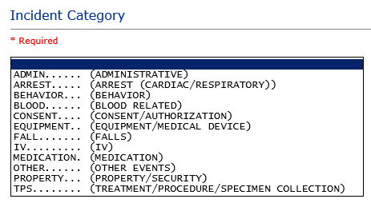

ADMIN sub category
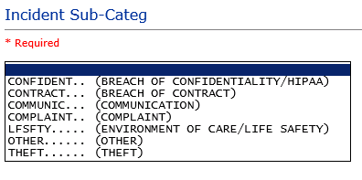
ARREST Sub Categories
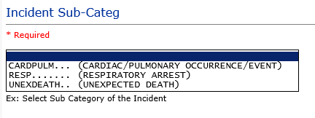

BEHAVIOR Sub Categories
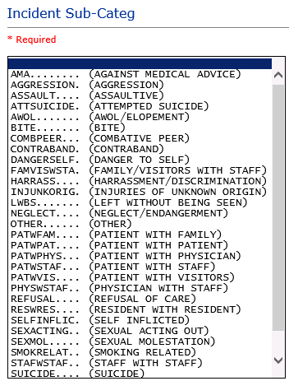
BLOOD Sub Categories
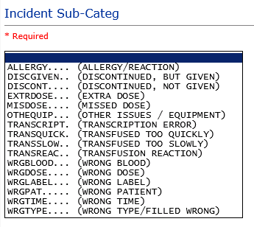

CONSENT Sub Categories
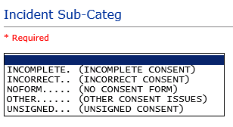
EQUIPMENT Sub Categories
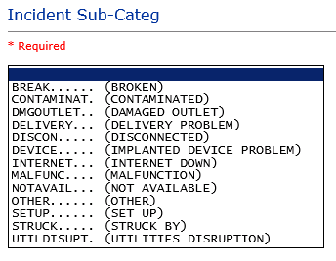
FALL Sub Categories
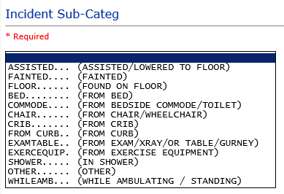

IV Sub Categories
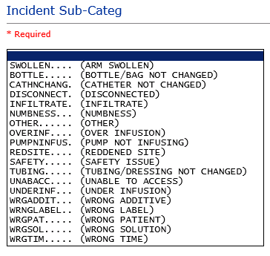

MEDICATION Sub Categories
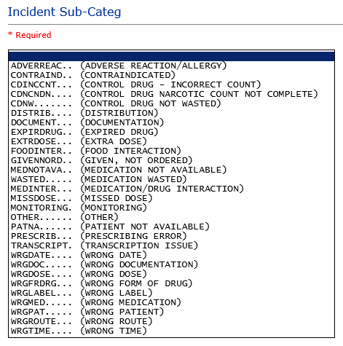

OTHER Sub Categories
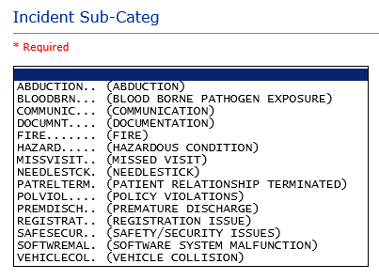
PROPERTY Sub Categories
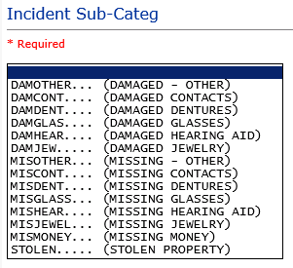

TPS – Treatment/Procedure/Specimen Collection Sub Categories
