- In Internet Explorer 8 and below go to Tools. In Internet Explorer 9 and 10 press the Alt key then go to Tools unless unhidden. 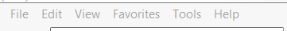

- Go to Internet Options.
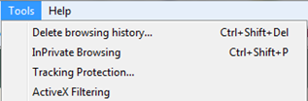

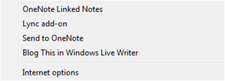

- Go to the Security Tab, click on Trusted Sites, and then Sites. 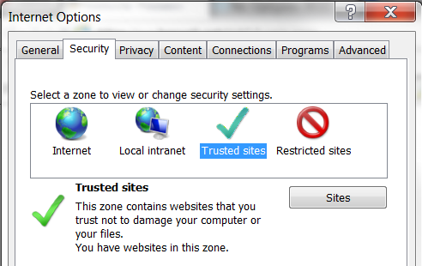

- Make sure the page you want is in the “Add this website to the zone” box and then press Add.

- 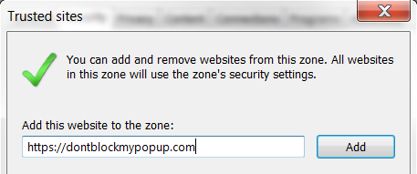

- To find out the address of the page, contact your RiskQual Support Representative and request the address for the HASWeb system

- If not an https site, uncheck “Require server verification (https:) for all sites in this zone” box. 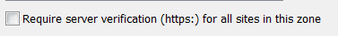
- Click on Close. 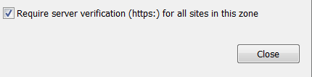

- Select Custom level.
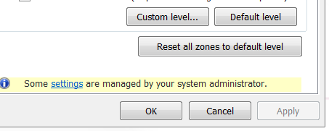

- Scroll down most of the way and verify Use Pop-up Blocker is set to Disable and click OK.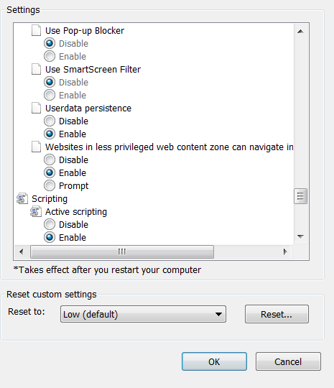

- Click OK.
- Webpage should now be running in Trusted Sites without pop up blockers.

